Lab Exercise - Create an Azure Functions App Using Azure Cloud Shell

Objective
In this lab, you will:
- Create a Function App
- Create a Storage Account
- Deploy a simple HTTP-triggered Azure Function
- Test the function

Prerequisites
- Azure subscription
- Access to Azure Portal
- Azure Cloud Shell enabled
Open:
Azure Portal
Then launch Cloud Shell using Bash.

Architecture
Cloud Shell
|
Resource Group
|
Storage Account
|
Function App
|
HTTP Trigger Function

Step 1: Create Variables
RESOURCE_GROUP=rg-function-lab
LOCATION=eastus
STORAGE_NAME=funcstorage$RANDOM
FUNCTION_APP=funcapp$RANDOM

Step 2: Create Resource Group
az group create \
--name $RESOURCE_GROUP \
--location $LOCATION

Expected Output:
ProvisioningState : Succeeded

Step 3: Create Storage Account
Azure Functions requires a storage account.
az storage account create \
--name $STORAGE_NAME \
--location $LOCATION \
--resource-group $RESOURCE_GROUP \
--sku Standard_LRS

Step 4: Create Function App
az functionapp create \
--resource-group $RESOURCE_GROUP \
--consumption-plan-location $LOCATION \
--runtime python \
--runtime-version 3.11 \
--functions-version 4 \
--name $FUNCTION_APP \
--storage-account $STORAGE_NAME \
--os-type Linux

Step 5: Verify Function App
az functionapp list \
--resource-group $RESOURCE_GROUP \
--output table

Step 6: Create Local Function Project
In Cloud Shell:
mkdir myfunctionproject
cd myfunctionproject

Initialize project:
func init . --python

Step 7: Create HTTP Trigger Function
func new \
--name HelloFunction \
--template "HTTP trigger" \
--authlevel "anonymous"

Step 8: Run Function Locally
func start

Expected Output:
http://localhost:7071/api/HelloFunction

Step 9: Test Function
Open another Cloud Shell tab and run:
curl http://localhost:7071/api/HelloFunction?name=Azure

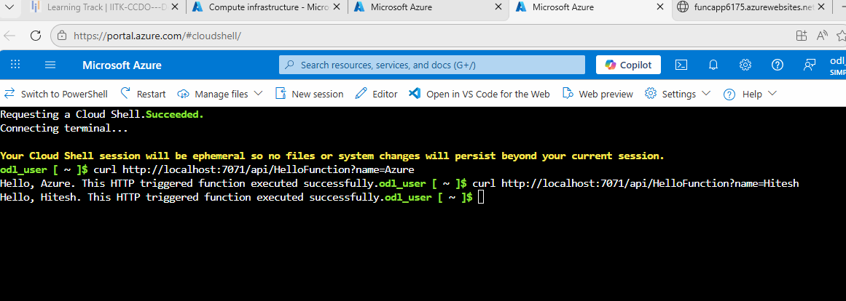
Expected Output:
Hello, Azure

Step 10: Deploy Function to Azure
func azure functionapp publish $FUNCTION_APP

Deployment may take a few minutes.

Step 11: Get Function URL
az functionapp function show \
--resource-group $RESOURCE_GROUP \
--name $FUNCTION_APP \
--function-name HelloFunction

Step 12: Test Azure Function
Use the generated URL:
curl https://<functionapp>.azurewebsites.net/api/HelloFunction?name=Cloud

Expected Output:
Hello, Cloud

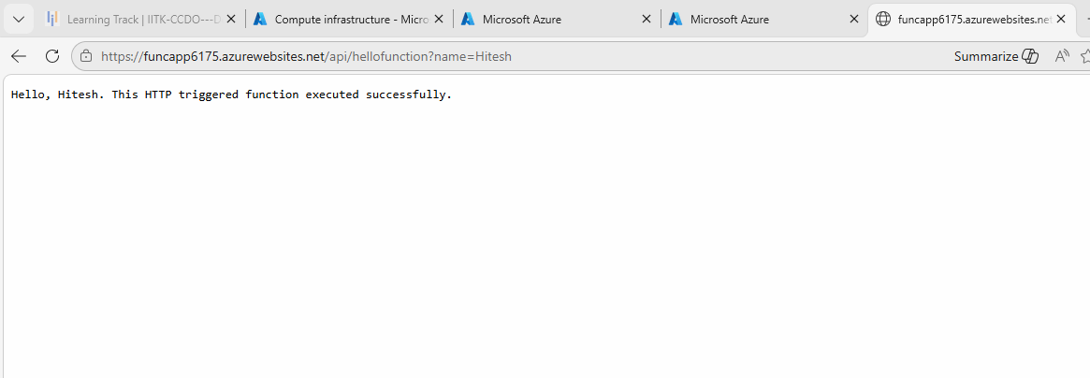

Cleanup Resources
Delete all resources after lab completion.
az group delete \
--name $RESOURCE_GROUP \
--yes \
--no-wait

Key Concepts Learned
Concept | Description
Serverless Computing | Run code without managing servers
Function App | Container for Azure Functions
HTTP Trigger | Function invoked using HTTP request
Consumption Plan | Pay only when function runs
Cloud Shell | Browser-based Azure CLI

Common Azure Function Triggers
Trigger | Purpose
HTTP Trigger | Web/API requests
Timer Trigger | Scheduled jobs
Blob Trigger | File upload events
Queue Trigger | Queue message processing
Event Hub Trigger | Streaming data

